Chapter 3, Solution 5

Obtain v₀ in the circuit of Fig. 3.54.

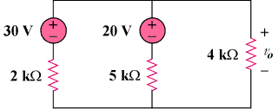

Figure 3.54
For Prob. 3.5.

Solution

Apply KCL to the top node.

v₀ = 20 V

